BRD - [MY] Smart Pickup - Manual Mapping Tool for PUP Group Geofence

| **Requestor** | MY Team |
| --- | --- |
| **Date requested** | February 28, 2023 |
| **Scope** | SPX system |
| **Priority** | P1 |
| **Reviewed by** |  |

**Revision history**

| **Date** | **Changes** | **Author** |
| --- | --- | --- |
| Apr 14, 2023 | First version | Zhengyu |
|  |  |  |

# 1 Overview

## 1.1 Business Background

In First Mile planning, the data layer is as follows:

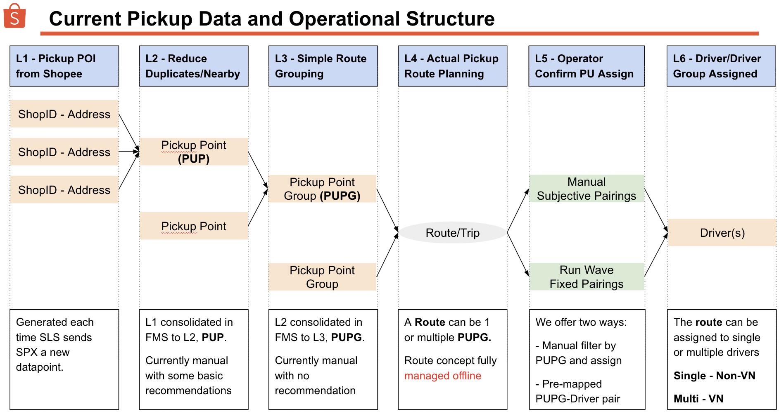

Each time a new shop is added or a new address is added for a shop, we create a new Pickup Point ID (PUP ID).

This PUP needs to be inserted into a PUP Group (PUPG) for Pickup Planning.

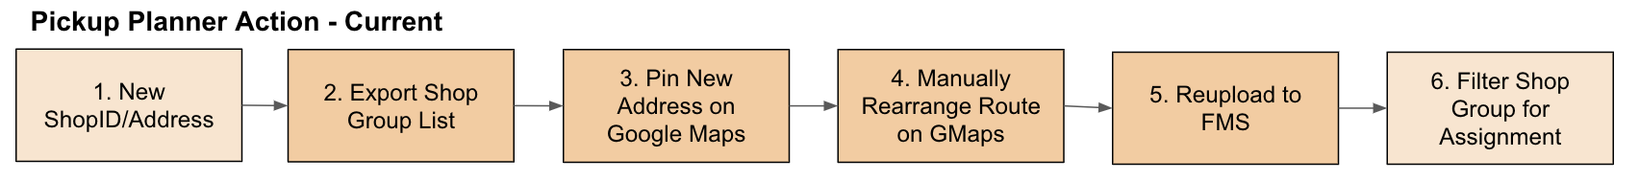

**Pain Points:**

When managing PUPG offline to individual drivers, there are several pain points:

1. **Difficulty to maintain PUPGs on street level** - user is **required to remember and read many street names** per area compared to current practice of doing so on ward level which is fewer and simpler (sometimes denoted by numbers)
2. **Poor integrated data visibility -** user **does not have supporting information during the route-arrangement** process. This reduces effectiveness of route planning. E.g. planned routes would have uneven ADO between routes.
3. **Harder to standardize the threshold for decision making -** Each planner of different hubs **has no standardized SOP** for planning. This makes the capacity planning of each route/courier to be inconsistent and vary widely.
4. **Inconsistent Planning Capability - Not all hub planners are equally capable.** Sometimes the original planner left and new planner come in, just try to keep the same route and minimize changes

## 

## 1.2 Business Objective

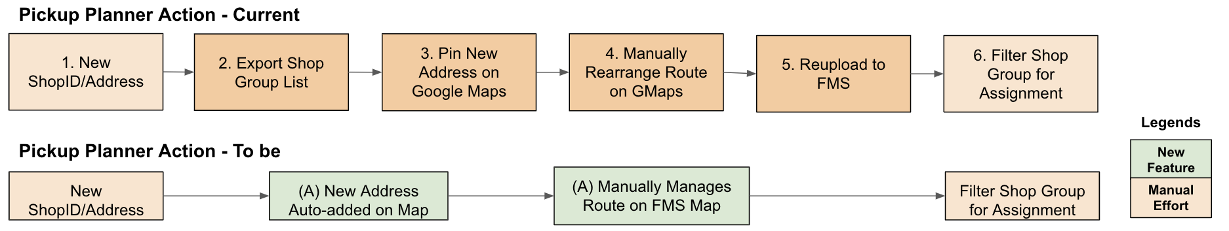

**Two objectives:**

1. To reduce the workload of planners doing step **2, 3, and 5**
2. Improve the **quality of work done in step 4**, by giving more supporting info/data

**This Feature comprises of 3 main parts**

* **Improvement to existing Pick Up Point Management:** 
  + (2.1) To add a tag for PUP with two values: 4w vs 6w
  + (2.2) Add PUP Management to the hub pages (currently only in admin page)
* **Improvement to Pickup Point Config**
  + (2.1) To add mode-switching between **Manual PUPG** and **Mapped PUPG**
  + (2.1) To add a clear whitelist management for **Mapped PUPG**
  + (2.2) Add PUP Config (PUPG) to the hub pages (currently only in admin page)
* **Pickup Zone Management and Drawing Tool**:
  + (2.3) Separate menu from Delivery Zone Management
  + (2.3) Allow ops to do drawing of the zones, system then define **“One PU zone = One PUPG”** for PUP Group Geofencing
  + (2.3) Additional logics specific to Pickup, e.g. display sellers pin, multi-layer zone…

# Please find below detail as the summary of the parcel flow

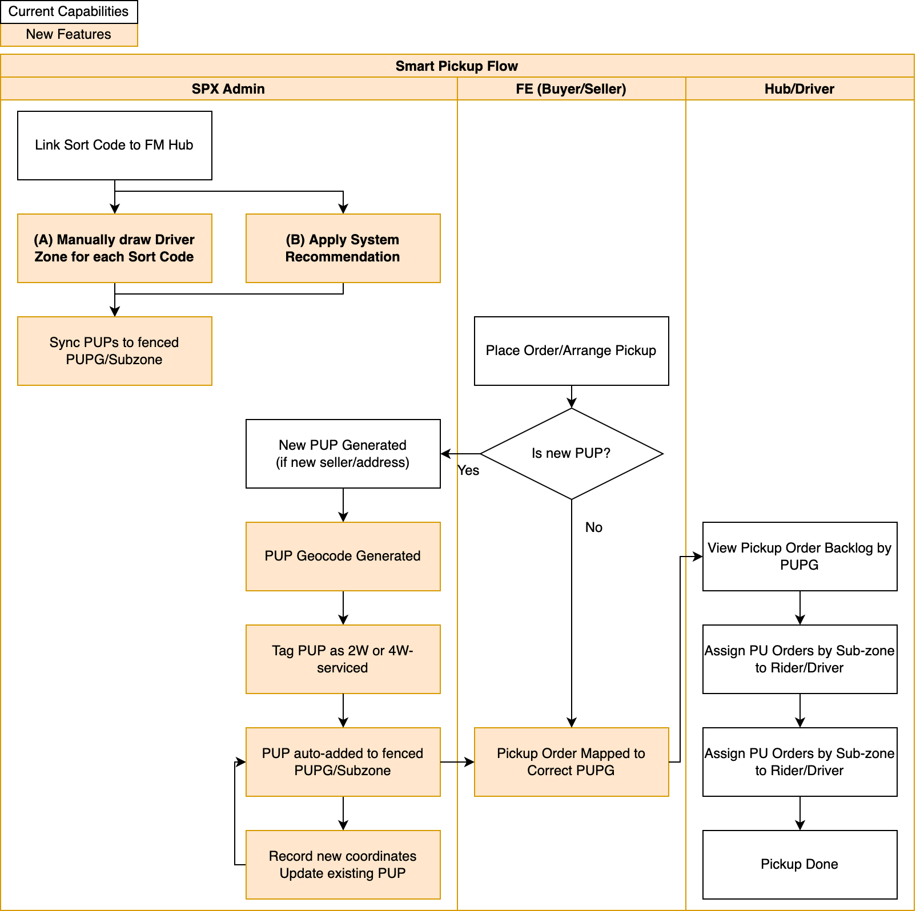

**Configuration and Maintenance**

1. Config in **SPX FMS**
2. Draw just like Last Mile Smart Sorting.
3. We expect low modification frequency

**Daily Operation**

1. System will auto-geocode all **new PUP/ShopID** and pin the PUP/ShopID onto existing map.
2. System auto-group **it into an existing route/PUPGroup**
3. Heavily reduced planner effort required on daily basis.

**Refinement**

1. When Pickup driver pickup order, actual coordinates are recorded.
2. If actual coordinates deviate from system-geocoded result, we **allow users to feedback actual PUP coordinates**.

# 2 Detailed Business Requirements

## Overall Change Expected Change in Menu

Black >>> Existing Page

Blue >>> New Page

| **Current** | **To-be** | **Rationale** |
| --- | --- | --- |
| **Admin**  **L1**  Pickup Management  **L2**  >>> Pickup Point Management  >>> Pickup Point Configuration | **Admin + FM Hub**  **L1**  Pickup Management  **L2**  >>> Pickup Point Management  >>> Pickup Point Configuration  >>>> Manual PUP Group  >>>> Mapped PUP Group | For clarity to users, we should separate the PUPG management for manual vs mapped |
| **NA** | **Admin + FM Hub**  **L1**  Smart Pickup Zone  **L2**  >>> Pickup Zone Management | Current Zone Mgmt menu is targeted for LM and is quite cluttered, so we should separate the new Smart Pickup L1 menu. |
| **Admin**  **L1**  Zone Management | **Admin**  **L1**  Smart Delivery Zone | To distinguish between FM and LM, we should rename the modules for user convenience. |

## 2.1 Improvement to Admin > Pick Up Management

**Summary:** PUP will now have a preferred vehicle value. Two values will be used, 4W and 6W.

Need to account for merging logic, which value should it take

We need to make 3 changes:

1. Change to the Pickup Point attribute to add Preferred Pickup Vehicle
2. Update this new attribute to PUPG as well
3. Create a new PUPG list for mapped PUPG vs the original manual PUPG list.

| **Area** | **Details** |
| --- | --- |
| **1. Pickup Point Management** | 1. **Additional attribute field - Preferred Pickup Vehicle**   **Field Name:** Preferred Pickup Vehicle  **Type:** Drop Down selection  **Values:** 4-Wheel, 6-Wheel (default value is **4-Wheel** for MY)  **Scope:** To be toggled on based on markets with Smart Pickup.  **Location:**   1. **Pickup Point Management > Pickup Point List page** - Add **column** after Text Address. Add **Filter** in search function      1. **Pickup Point Management > PUP Details page -** Add **field** under Type     **Note:** There are other vehicle types, but for the purpose of MY trial, we are only going to cover these two vehicle types hence only giving 2 values to this drop-down.  Any non-4WH, e.g. truck, etc can be temporarily grouped under 6W   1. **Additional attribute field - PUP Geolocation**   **Field Name:** Geo-location  **Type:** Lat/Long  **Scope:** To be toggled on based on markets with Smart Pickup.  **Location:**  **Pickup Point Management > PUP Details page -** Add **field** under Text Address     1. **Logic for Merging Pickup Point**   How to support the new tag and geolocation when Pickup Points are merged  **Logic:** Same as Text Address logic. When PUP A (parent) merge in PUP B,   * PUP B will disappear * PUP A will keep its Preferred Pickup Vehicle and geolocation * PUP B will be added to the table inside PUP A detail page * Summary confirmation page to add PPV value column * PUP detail page to add PPV column      1. **Batch Action**   Need to add the PPV, Geolocation (lat, long) column for   * Mass PUP Create * Mass PUP Update Information   Log will include these three columns as well |
| **2. Pickup Point Configuration** | 1. **Pending Group**   This page will just need to add   1. **Preferred Pickup Vehicle** column. Position after “**Text Address**” column. 2. A Filter selection for PPV. 3. **Pickup point Group**   **Logic:** Each Pickup Point Group will have the same attribute **Preferred Pickup Vehicle.**  PUPs inside a PUPG do not have to have the same PPV value as the Group it is in.  Also need to add   1. PPV column after Group name 2. PPV filter 3. PPV row inside the “View” and “Edit” popup 4. **Batch Action**   Mass Update to add PPV column |
| **3. PUP Group Logic** | **Current Manual PUPG Logic:**   * Multiple PUP can be added to PUPG * Multiple PUPGs co-exist, but the PUPs inside them are mutually exclusive   **Request:**   * To create another list of PUPG. * **List 1 - Manual PUPG:** is what we have right now. * **List 2 - Mapped PUPG:** is the new list of PUPG. * List 2 will be in the new page, “Mapped PUPG” * We require hard coded control of this new page by market. And within each market, we need hub level control.   **Input Logic**   * **List 1 - Manual PUPG**   + List 1 remains as current. There will be two tabs, Pending Group, and PUPG list. * **List 2 - Mapped PUPG**   + **Workflow:**     - **I create a version A. it goes live**     - **Version A data populate this Mapped PUPG module**     - **I create version B, it goes live**     - **Version B data takes over this whole Mapped PUPG module**     - **The Mapped PUPG module data is based on the current hub version**   + List 2 will have three tabs, a) Mapped PUP Review, b) Mapped PUPG list, and c) PUPG Whitelist.   + **This Mapped PUPG module requires some special requirements:**     - Display the current Version name and clicking View will lead to the Pickup Zone Management tool page.     - In Admin, there needs to be a Hub filter.     - The content of the Mapped PUPG list is from the sum of all active versions of each zone.     - If the version of a zone is updated or changed to a new version, the PUPG under that zone will be updated as well.   **Three tabs to show**  **1. Tab “PUP Review”**   * + Content of this list:     - List out all PUPs that have been added automatically to the PUPG of this hub (ie PUP falls under geofence in this version since the latest active version.       * PUP added due to new addresses/shopID       * PUP added due to sort code changes   + The columns required are:  | **Field** | **Description** | **Remark** | | --- | --- | --- | | PUPID | PUPID |  | | PUP Name | PUP Name |  | | Number of Shops | Number of shopID consolidated into the PUPID |  | | District | Taken from Address L3 |  | | Text Address | Taken from order creation request |  | | PUP Auto Add Date | Date and time value | Date the PUP appears in this list | | Mapped PUPG | PUPG Name that the PUP is mapped to. Can be blank. | This value is based on the Mapped PUPG that contains this PUP | | Preferred Pickup Vehicle Type | Preferred pickup vehicle type, either 4W or 6W |  | | Hub | Parent hub of the PUP |  | | Publish Date | Date and time value | Most recent date the parent PUPG has been published |   **2. Mapped PUPG List tab**   * + This tab list out all PUPG mapped by system. All PUPG here are generated by system based on current mapping result of the route. User cannot create new PUPG or edit PUPG here.   + PUP also cannot be moved between PUPG directly in this page.   **3. PUPG Whitelist tab**   * + This tab displays all currently whitelisted PUP that is added to PUPG out of the expected PUPG zone.   + PUPG whitelist management on hub level is done in Pickup Zone Management using 2 ways: 1) add one by one to selected PUPG, 2) mass upload whitelist PUP and PUPG mapping      * + Operator will create a new whitelist entry, and indicate the PUPG they want it to be whitelisted to. The PUPG available for selection are only those that fall into hub serviceable area or are whitelisted to the selected hub.   + Each entry is for one PUP.   + The contents required are:  | **Field** | **Description** | **Remark** | | --- | --- | --- | | PUPID | PUPID |  | | PUP Name | PUP Name |  | | Number of Shops | Number of shopID consolidated into the PUPID |  | | District | Taken from Address L3 |  | | Text Address | Taken from order creation request |  | | Mapped PUPG | PUPG Name that the PUP is mapped to. Can be blank. | This value is based on the Mapped PUPG that contains this PUP | | Preferred Pickup Vehicle Type | Preferred pickup vehicle type, either 4W or 6W |  | | Hub | Parent hub of the PUP |  | | Publish Date | Date and time value | Most recent date the parent PUPG has been published | |

## 2.2 Addition of “Hub > Pick Up Management”

Currently, there is no pickup management module in Hub page.

Pickup Management, PUP management, PUP config, are only available in Admin page.

| **Hub > Pickup Management > Pickup Point Management** | **Request**   * Add the PUP Management page to Hub level page   **Data scope**   * Only display new PUP within the pickup sort code area of this hub, and PUP whitelisted into this hub |
| --- | --- |
| **Hub > Pickup Management > Pickup Point Group Config** | **Request**   * Add the PUP Config page to Hub level page, rename to Pickup Point Group Config. * This applies to both Manual and Mapped PUPG Page   **Data scope**  There will be both the manual and mapped PUPG mode:   * Same 3 tabs, PUP Review, Mapped PUPG list, and the PUPG Whitelist page. * However, the data scope will be restricted. * Pending Group list will only display new PUP within the pickup sort code area of this hub, and PUP whitelisted into this hub * PUP Group list will only contain PUPG created by the map |

## 2.3 Admin > Smart Pickup Config

Currently we have zone management module used for smart sorting.

Objective is to enable the smart pickup functions at a minimal impact to user experience and confusion.

| **Menu tree for Zone Management** | **New Menu sequence**  Objective is to enable clear navigation   1. **Zone Management** change to **Smart Delivery Zone** 2. New menu **Smart Pickup Zone**    1. New menu **Pickup Zone Management** |
| --- | --- |
| **Admin > Zone management > Pickup Zone Management** | * Under **Admin > Smart Pickup Zone > Pickup Zone Management** to display 4 main tabs,(Same as smart sorting solution) * The list contains unique versions of each hubs.   + **Active**: Active hub version at the moment     - Each hub only has 1 active zone version     - At initialization, it is possible for a hub to not have an active version     - If no active version exist, PUPG for that Hub will follow the manual version     - User should be able to retire an active version for any hub anytime   + **Upcoming**: Zones that have already been set up and will be effective in the near future   + **Expired**: Old zones that have been active in the past   + **Draft**: Zones that are still in draft      * Under each version will have the **whitelist sellers.** * For PUPs outside the hub boundary (ie pickup whitelisted to that particular hub), a PUPG whitelist mapping review is shown to allow user to confirm that PUPs are whitelisted / auto-mapped to the correct zone. |
| **Manual Pickup Zone creation** - 1. Initiation | **Creation Process**   * Go to Pickup Zone Management * Users can click Create * Select the Hub to create a new zone version. * Selection is limited to FM and SOC station type. (All Mile Hub when live) * The drawing boundary is the SOC serviceable area.   + For most SOCs, they cover one or multiple provinces, so the hub boundary is the province boundary or the combinations of multiple province boundaries.   + For 3 SOCs, besides the major provinces they cover, they extend a small part from another province. Examples are: SOC KDH (slightly extend into Kedah), SOC DDR (slightly extend into Terengganu), and SOC NS9 (slightly extend into Johor). For these SOC, local team needs to draw the boundary and send the polygon file to dev for one-time set-up purpose. * Along with the drawing boundary, also display the current hub zone boundary as a reference line to help the user to draw the zone (purpose is to help user to easier determine the zone belong to which hub)   + This reference line will have no constraint on the drawing process (i.e. user can still draw a zone crossing the reference line) |
| **Manual Pickup Zone creation -**  2. Zone management interface | When either creating or editing, we will have the same interface as last mile smart sorting.  The required elements are   * **Drawing tool**s displayed on top bar * **Map visualization** highlight of exact area of this hub. Data is based on pickup sort code parameter * **Zone list** to display zone created so far   **Drawing tool required:**   * Splitting zone * Merging zone * Editing zone * Deleting zone * Searching zone * Property setting * (for setting up the zone ID, zone name, zone type) * (follow the zone drawing and management tool/function from SS)   **Drawing Methods:**   1. **Manual point to point drawing**    1. Current method used in last mile zone drawing tool    2. Polygons must be fully enclosed    3. PUPs will only be considered within zone if it is inside.    4. Ideally users need to draw 100% of serviceable area    5. **High effort** 2. **Manual cluster drawing with Auto-map**    1. Polygons still must be fully enclosed.    2. PUPs not inside zones will be auto-mapped to the nearest zone mid-point based on straight line distance.    3. Users need not draw 100% of the serviceable area.    4. **Medium effort** 3. **Quick draw**    1. Similar to Last mile Smart Sorting, to develop the auto generate zones function based on       1. Unit （Based on the latest version of Address Servcie Platform>Unit Management)       2. Street       3. District |
| **Manual Pickup Zone creation** - 3. Creating new driver zone and saving  (manual draw) | * Once ops team confirm selected the hub, system will display the hub coverage on the map * After ops team finish and confirm drawing the zone, to allow them to set the zone ID, zone name, zone type   + Zone ID:     - Free text     - Mandatory field     - System validation to ensure that there is no duplicate zone ID (only allow duplicate hub zone ID when both of the zones are not under “Active”at the same time)   + Zone name (same as SS)     - Free text     - Mandatory field     - System validation to ensure that there is no duplicate zone name (only allow duplicate hub zone name when both of the zones are not under “Active”at the same time)   + Zone Type (same as SS)     - Free text for ops to input zone type e.g. residential area, office area etc.     - By Optional field |
| **Manual Pickup Zone creation** - 4. Validation | * Validation (might be different from SS)   + We can accept two scenarios:     - Total hub coverage area has been fully drawn and covered, with no overlap       * Follow current LM Smart sorting logic     - Some areas have been drawn, but not fully covered, no overlap      * + - * Prompt a popup to inform users, either can proceed to publish or return to editing       * If proceed, System will take it as user wants system to use smart distancing to group PUPG from this point onwards         + Auto-map result will be shown to users for confirmation       * If return to editing, User can keep on editing |
| **Effective date** | * To add the “effective date” function for ops team to clearly define at what date and time this update zone should be effective |
| Calculating ADO and the size of each zone | * Atter ops finishes creating the zone, system needs to calculate the zone ADO based on past 30 days historical order volume for that specific area * Also, system will need to calculate the size of each zone (Square Km) |
| Export | * Allow ops to export the existing zone info from the system where the exported file will be as follow   + Zone ID   + Zone Name   + Hub   + Zone type   + Operator   + List of Longitude   + List of Latitude   + Zone Creation date and time |
| Log | * Allow ops team to check the log of any changes that happens to the zone   + Create/Edit/Merge/Split/Delete of zones |

## 2.4 Addition of Hub > Smart Pickup Config

| **Function** | **Details** |
| --- | --- |
| Hub> Smart Pickup Config | * Similar to Admin, Hub page will also need to have their own Pickup Zone Management * Function list will be similar   + Pickup Zone Management * Data scope:   + Limited to only their own hub PUP and PUPG      * The rest of the function will be the same as Driver zone management in Admin |

## 2.5 Detailed Requirement of Drawing Tool

During the drawing process, Pickup Planner will require extra informations as follow

| **Function** | **Details** |
| --- | --- |
| **1. ADO overlay** | * Existing LM Zone mgmt tool already have the ADO overlay by administrative area. We can follow the same overlay design to help with planning. * ADO monitoring of zones is to help planner decide whether redistribution of zone is needed * **Request:**   + After a zone is drawn, system to auto calculate ADO.   + ADO is displayed in 1) zone list, 2) Tooltip popup while hovering over the zone area |
| **2. PUP Pins display** | * Sellers distribution is different from buyers’ distribution due to significantly smaller total numbers. * Planners rely on the **visualization of pins** to decide the zone boundary. * We need to assess the current density * Considerations:   + Only display pins for sellers with pickup orders within L30D OR PUP created time is within L30 days   + Pin color will be based on zone (1 color = 1 zone) |
| **3. Preferred Pickup Vehicle Layer** | * The active map for each hub needs to have **two layers**, allowing users to toggle between them, **4W layer**, and **6W layer.**      * Anything non-4W will be treated as 6W for simplicity of planning. * There should be a clear indicator, either by tag or color coded to make sure users know they are viewing 4W or 6W layer. * **Pin display logic -** when users open each layer (4W or 6W), we should **only show the pins of PUP with the same PPV value**. If 4W layer, only show 4W pins, if 6W layer, only show 6W pins. * Some areas will overlap 4W and 6W, but some areas will only be served by one type. We need to help users make sure all space in the hub is covered by at least one type.   >>> We need to let users view both layers at the same time. Highlight the unmapped areas after both are displayed. |
| **4. Historical Driver Visualization** | * Display historical pins of PUPs drivers were at during a specific selected period * Each driver is one color * Historical data will show up depending on the layer user looking at. E.g. if looking/editing 4W layer, only show 4W drivers historical data * Only PUP pins or historical pins can be toggled on at one time. When driver visualization is on, hide PUP Pins to reduce clutter |
| **5. Satellite Street View** | Satellite view could help the user to know the building front facing direction so that they can choose the road as the zone boundary more easily. This feature is available in LM, and also need to be applied to FM. |

## 2.6 Access control for zone creation and management

| **Function** | **Details** |
| --- | --- |
| Access control for zone creation and management | * To add the access control to help to better manage and control who can create and manage the zone * Create access control based on the following   + - View zone only     - View and create/manage/edit zone     - Export   Limit the hub access to manage zone only in that hub |

## 2.7 PUP Geolocation

| **Function** | **Details** |
| --- | --- |
| Obtaining and Maintaining seller geolocation | * We want a few potential inputs for PUP Geodata:   1. When the pickup driver performs the pickup task at the PUP, we record the coordinates to be used as PUP coordinates. For PUP with multiple coordinates far apart, we need to have a special logic to exclude outliers.   2. Manual update inputs by operators. Manual inputs should overrank all other methods.   3. Coordinates based on buyer’s address database used in smart sorting. * FPMs will propose further logic to improve the accuracy of PUP geolocation   Ops is allowed to edit PUP geolocation / coordinates in PUP Management > Edit Pickup Point (see Pickup Point Management under Section 2.1). Once updated, this PUP will be re-mapped based on the manual input geolocation. |

## 2.8 Auto-Mapping PUP to Pickup Zones

| **Function** | **Details** |
| --- | --- |
| Logic for linkage | There are two possible scenarios of changes:   1. **New Pickup Zone version**    1. **Manual update -** Due to re-zoning pickup zones    2. **Auto update** - Due to serviceable area changes 2. **New PUPs are added with new orders**   How we handle each situation are below:   1. **New Pickup Zone version (manual update)**   Each time a new Pickup Zones Version for a hub is published, system will   * 1. Pull out all PUPs within the serviceable area of the hub   2. Link these PUPs to respective Zones drawn in that version   3. A PUPG is created based on each of the Zones in this version, and will contain all the PUPs linked in (b). The name of the PUPG is the name of the zone.   4. Pull out the following special PUPs      1. PUP L3 not within the Hub serviceable area but whitelisted to a PUPG within this Hub.         1. A PUPG generated by smart pickup can be easily identified as “**within hub”**         2. In case where no previous smart PU version, within each PUPG, arrange the PUPs by hubs. The hub with > 80% of the PUP will be the hub this PUPG **belongs to.**         3. Hub whitelist need to be done first before PUPG whitelist to one of the hub’s zones can be done   5. This PUPs list from the pickup whitelist has to be **handled.**      1. Table display with each PUP is one row.      2. “Whitelisted PUPG Zone” is displayed for user to review   6. In the case where several child PUPG are merged into a parent PUPG (and published), when the user opens assign driver page and search by parent PUPG, can find all the PUP included in the child PUPG.  1. **Sorting Code Adjustments (auto update)**   **Scenario**  There are two hubs with drawn Pickup Zones, called Hub A and Hub B.  User changes a Pickup sort code from Hub A to Hub B.  **Expected Impact to Mapped PUPG**  A new version of PUPG zone is automatically created when serviceable area changes, with the following auto updates:   1. If drawn zone PUPG of Hub A wholly belong inside the transferred pickup sort code area    1. This zone and PUPG is removed from Hub A mapped PUPG list    2. This zone and PUPG is auto-added to Hub B    3. The name and ID of this zone is <“**Original value**” + “**_(Auto)**”>. This should help to flag out the auto-updated zones due to PU sort code change. 2. If drawn zone PUPG of Hub A is partially in the transferred pickup sort code area    * 1. Original zone in Hub A will have its area updated, cut off exactly at the line of the pickup sort code that is transferred to Hub B      2. The cutoff part of this original zone will auto-create a new zone in Hub B together with all the PUP inside its geofence.      3. The name and ID of this zone is <“**Original value**” + “**_(Auto)**”>. This should help to flag out the auto-updated zones due to PU sort code change.      4. The PUPs geofenced to the cutoff area 3. PUPG whitelist for the new version is refreshed (ie whitelist is cleared out), but user should be able to see the previous whitelist in the version history 4. **New PUPs are added**   Each time an order is added with a new address, and a new PUP is generated:   1. Get coordinate for PUP 2. Locate the PUPG for this PUP based on the active hub version 3. Auto-add the PUP to the PUPG   **Important:**  At the end of each day, operator of each hub would want to see all the PUPs that have been   1. Automatically added to the serviceable area of their hub 2. Automatically added to PUPGs in their hub   This will show up in the **PUP Review tab** of the Mapped PUPG Management Page (Refer to 2.1)  We will have the updated date and time for user to filter latest changes. |

## 2.9 Creating assignment task

| **Function** | **Details** |
| --- | --- |
| **Pickup > Pickup Assignment (Manual)** | Assign Driver   * The assign to driver process will be same as current * Click on Assign Driver (New)      * New Assign page will open. * **Current Design:**   + One filter for “Pickup Point Group” * **Request:**   + Users need to clearly know which PUPG they are referring to   + New filter to choose PUP Group Type (Manual or Mapped)      * + If Manual is selected, “Pickup Point Group” filter will only show manual PUPGs     - This filter only show the PUPGs manually created in list 1     - This will not show the PUPGs created by smart pickup zones   + If Mapped is selected, “Pickup Point Group” filter will only show mapped PUPGs     - This filter only show the PUPGs created by the smart pickup zones.     - Only PUPGs created within the hub sort code area will be selectable     - When new versions of hubs smart pickup zones are activated/updated, the PUPGs list need to be updated accordingly     - A new column for Preferred Vehicle Type (4W / 6W) is added to the table     - A new column for Seller Address is added to the table     - A new filter for Preferred Vehicle Type is also added     - Mapped PUPGs will be labeled with [4W] or [6W] depending on the map layer it was created from (i.e. zoneA from 4-wheeler map will be labeled as “[4W] zoneA”) User should be able to fuzzy search [4W] / [6W] to filter out the corresponding PUPGs from the filter list.     - This filter will be fuzzy-searchable   Current page for reference |
| **Pickup > Pickup Assignment (Wave)** | Create Route   * Mapped PUPG is added to route type under route configuration   + If mapped PUPG is selected, only PUPGs created by the smart pickup zones are shown for selection   + If manual PUPG is selected, only manually created PUPGs are shown for selection   + A route can only have either manual or mapped PUPGs linked to it   Create Pickup Wave Rule   * Only route IDs with the same type (manual PUPG / mapped PUPG) are allowed to be in the same rule   + If a mapped PUPG route is selected, only other routes using mapped PUPG can be added to the rule   + If a manual PUPG route is selected, only other routes using manual PUPG can be added to the rule * Group type is added to the pickup wave rule list for visibility   Schedule Pickup Wave Run   * For both admin and hub level, a new filter for Group Type (Manual PUPG / Mapped PUPG) is added * In the hub level, the run wave scheduler will have a “Run Wave by Mapped PUPG” toggle to run wave by mapped or manual PUPG      * + When toggled on, only wave rules with group type = Mapped PUPG are run regardless of status   + When toggled off, only wave rules with group type = Manual PUPG are run regardless of status   + There should be permission access tied to this toggle and only those with permission from SOUP can use this toggle   + A log is also added to track the changes done to the toggle * In admin level, a new Run Wave by Mapped PUPG tab is added to track the overall status of each hub’s toggle (ie which group type it is running)   ​​ |

## 

## 2.10 Initializing PUPG zones using historical data (one-time setup for all SOC)

In order to support MY’s rollout to SOCs, they require help in generating the PUPG zones as manual initialization takes a lot of time and effort from ops.

The expected operational flow for PUPG initialization will be as follows in the initial phase:

* BPM to provide file with PUPG zone polygons based on historical pickup data (logic below)
* MY team to import PUPG zones to FMS using “Upload Pickup Zones”
* MY team to use a) Historical Driver Visualization and b) Actual PUP location and ADO as reference to adjust initial PUPG zones, if needed

| **Area** | **Details** |
| --- | --- |
| **Initial Polygon Creation Logic** | Background:  Since the daily pickup volume varies a lot during a week. On Sunday, there will be less pickup volume and Monday there will be a surge in pickup volume.  To deal with this daily fluctuation, the operation team could initialize 3 versions of PUPG zone and switch among normal days, peak days and low-volume days.  We will use a trial hub to initialize first and determine whether to apply the same logic to other hubs if auto-merging significantly saves time vs. manual merging from unit polygon.  Scope: Trial SOC will be provided by local  Versions of merging & corresponding order raw data:   1. **Normal version:** L3M Order with pickup scan date between Tuesday to Saturday (but excluding all the campaign days) 2. **Peak version:** L3M Order with pickup scan date equal to Monday 3. **Low-volume version:** L3M Order with pickup scan date equal to Sunday   Merging logic:  Merge the zone based on target ADO range (min & max) provided by local team.  Naming logic:   * Unit ID: *(zone)***-***(area name)***.***(polygon number in area)***-***(building type)* (e.g. A-BPCH.1) * Driver ZoneID: *(zone)***-***(driver number per zone)***-***(area name)***.***(polygon number in area)***-***(building type)* (e.g. A-01-BPCH.1) |

## 